**Machine Learning Lab**

**Assignment 4**

**Name - Pritesh Kumar Sahani**

**Roll - 001811001005**

**Semester - 7**

**Year - 4**

**Department - Information Technology**

**GITHUB LINK:** [**https://github.com/stepupgithub/Machine-Learning-Assignments**](https://github.com/stepupgithub/Machine-Learning-Assignments)

**ENTIRE ASSIGNMENT LINK (GOOGLE COLLAB + COMPARISON TABLE):** [**https://drive.google.com/drive/folders/1uJKro7MbEk19yvFoiNcMpD6txP8NevG8?usp=sharing**](https://drive.google.com/drive/folders/1uJKro7MbEk19yvFoiNcMpD6txP8NevG8?usp=sharing)

**1) *Partition based: K-means***

**1.1) IRIS PLANT DATASET**

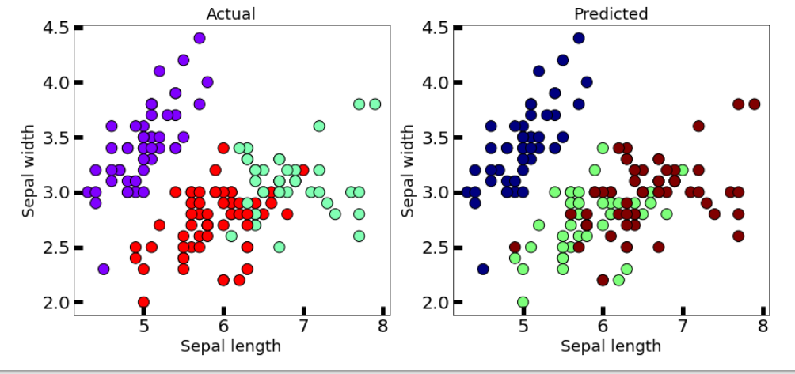

**1.2) WINE DATASET**

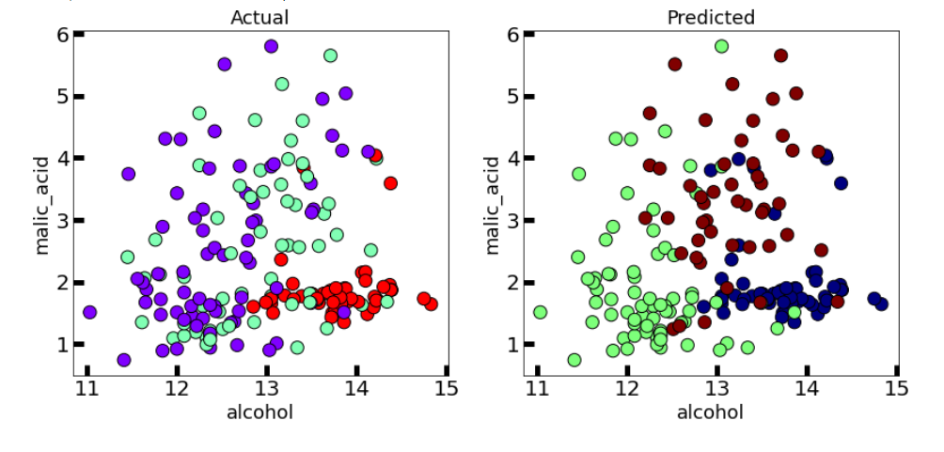

**This algorithm generalizes to clusters of different shapes and sizes, such as elliptical clusters. The problem with it is that we need to manually choose the value of “k”.**

**2) *Partition based: K-medoids***

**2.1) IRIS PLANT DATASET**

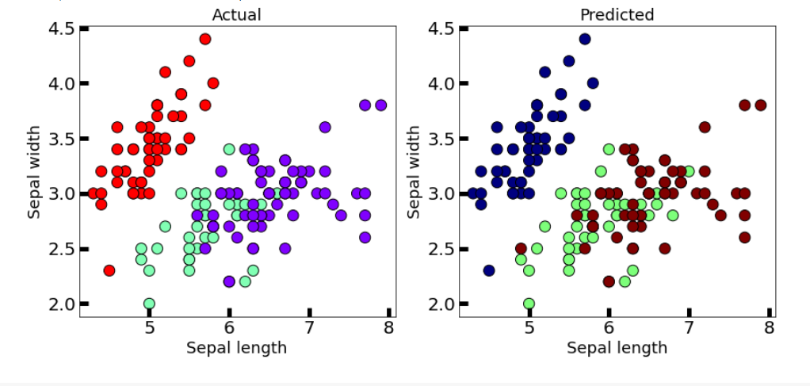

**2.2) WINE DATASET**

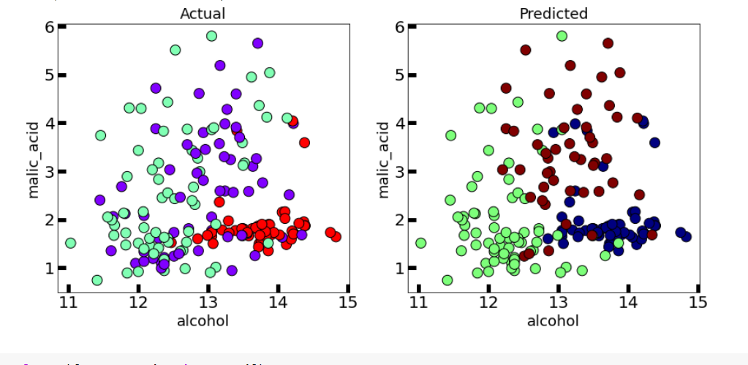

**This algorithm solves the problem with the K-means algorithm.**

**K-means attempts to minimize the total squared error, while k-medoids minimizes the sum of dissimilarities between points labeled to be in a cluster and a point designated as the center of that cluster..**

**3) *Hierarchical: Dendrogram***

**3.1) IRIS PLANT DATASET**

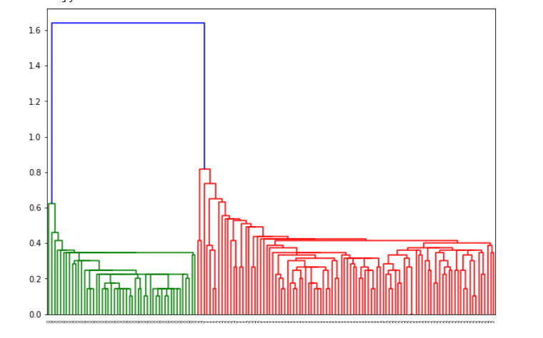

**3.2) WINE DATASET**

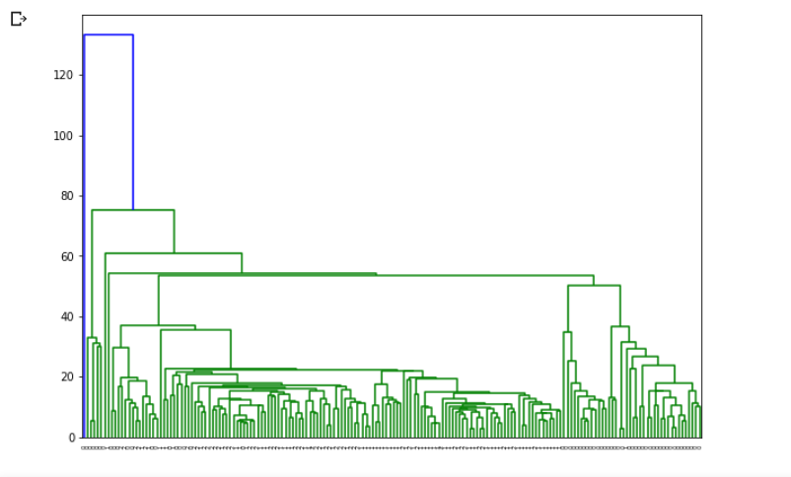

**A dendrogram is a diagram that shows the hierarchical relationship between objects. It is most commonly created as an output from hierarchical clustering. The main use of a dendrogram is to work out the best way to allocate objects to clusters.**

**4) *Hierarchical: AGNES***

**4.1) IRIS PLANT DATASET**

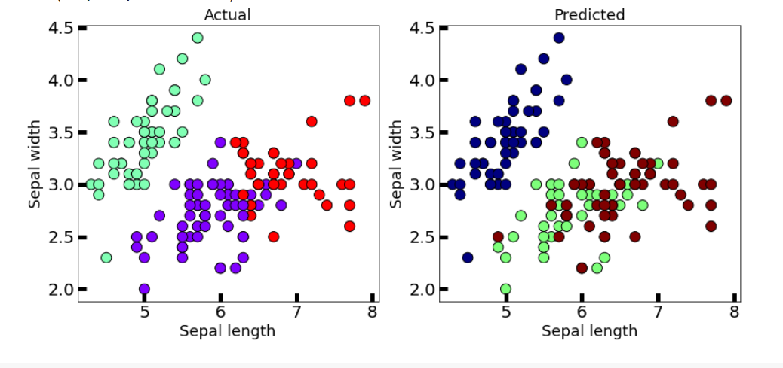

**4.2) WINE DATASET**

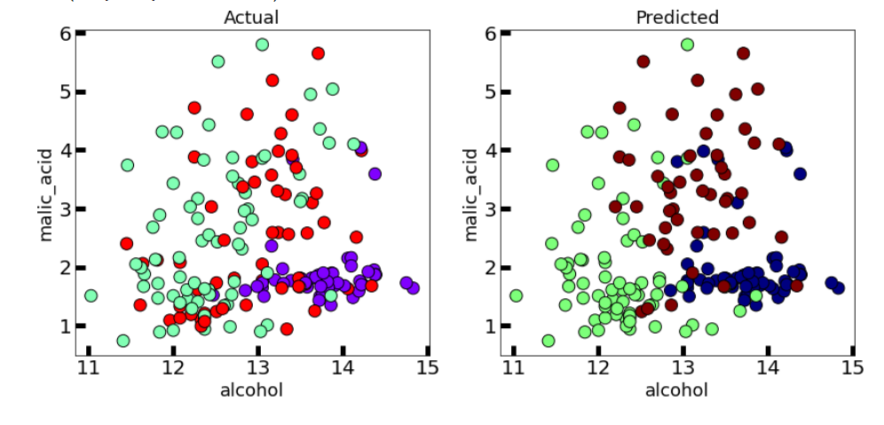

**The agglomerative clustering is the most common type of hierarchical clustering used to group objects in clusters based on their similarity. It’s also known as AGNES (Agglomerative Nesting).**

**The algorithm starts by treating each object as a singleton cluster. Next, pairs of clusters are successively merged until all clusters have been merged into one big cluster containing all objects.**

**The result is a tree-based representation of the objects, named dendrogram.**

**5) *Hierarchical: BIRCH***

**5.1) IRIS PLANT DATASET**

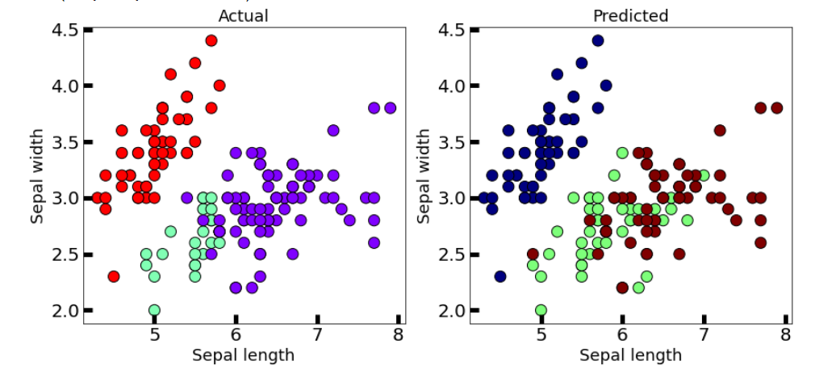

**5.2) WINE DATASET**

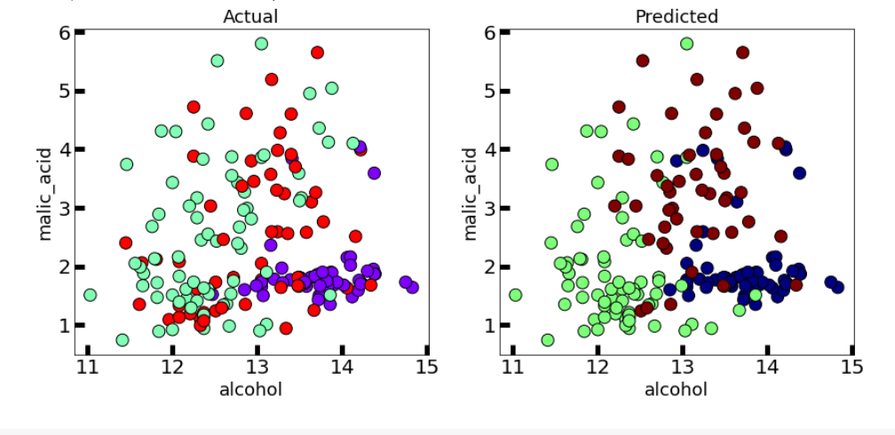

**Balanced Iterative Reducing and Clustering using Hierarchies (BIRCH) is a clustering algorithm that can cluster large datasets by first generating a small and compact summary of the large dataset that retains as much information as possible.**

**This smaller summary is then clustered instead of clustering the larger dataset**

**6) *Density based: DBSCAN***

**6.1) IRIS PLANT DATASET**

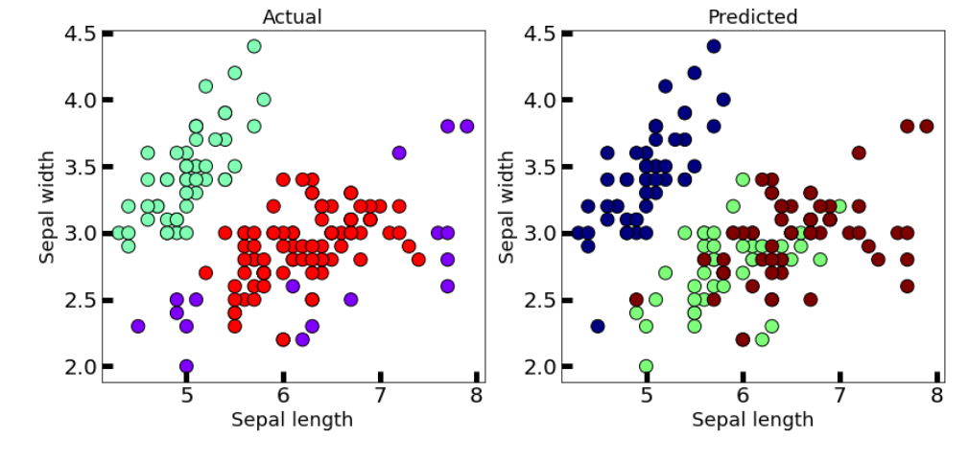

**6.2) WINE DATASET**

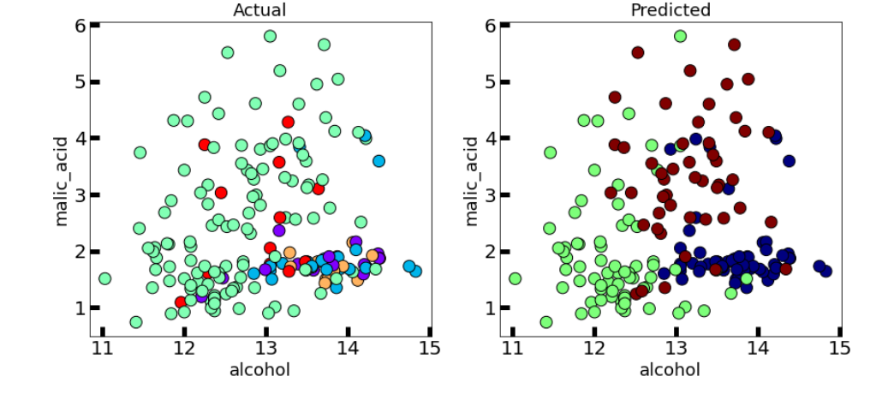

**Clusters are dense regions in the data space, separated by regions of the lower density of points. The DBSCAN algorithm is based on this intuitive notion of “clusters” and “noise”.**

**The key idea is that for each point of a cluster, the neighborhood of a given radius has to contain at least a minimum number of points.**

**7) *Density based: OPTICS***

**7.1) IRIS PLANT DATASET**

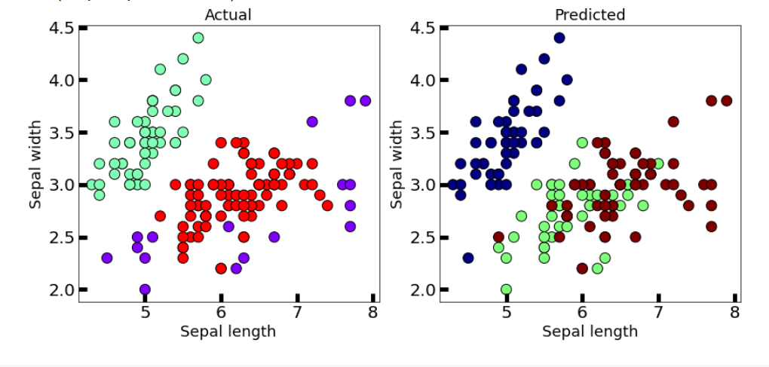

**7.2) WINE DATASET**

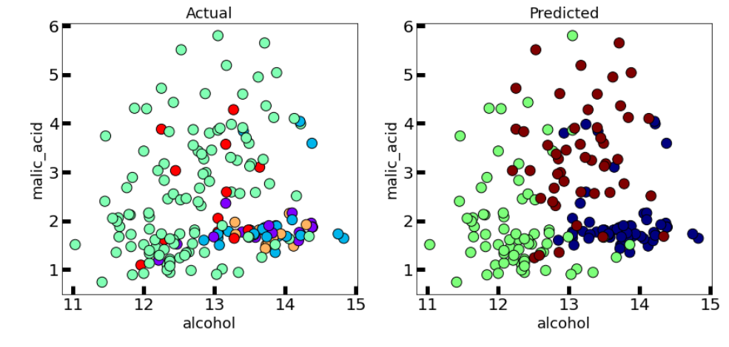

**This clustering technique is different from other clustering techniques in the sense that this technique does not explicitly segment the data into clusters.**

**Instead, it produces a visualization of Reachability distances and uses this visualization to cluster the data.**

**8) *K-means++***

**8.1) IRIS PLANT DATASET**

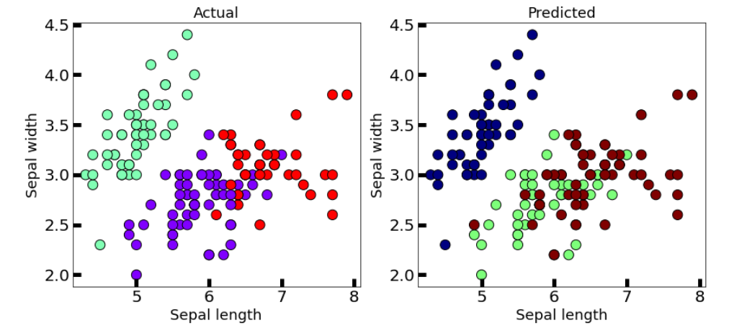

**8.2) WINE DATASET**

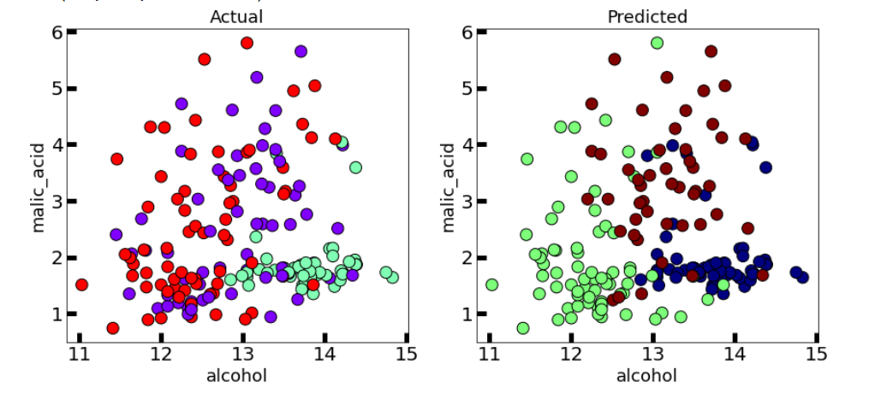

**In the case of K-Means clustering, we were using randomization. The initial k-centroids were picked randomly from the data points.**

**This randomization of picking k-centroids points results in the problem of initialization sensitivity. This problem tends to affect the final formed clusters. The final formed clusters depend on how initial centroids were picked.**

**K-Means++ solves the above problem.**

**9) *Bisecting K-means***

**9.1) IRIS PLANT DATASET**

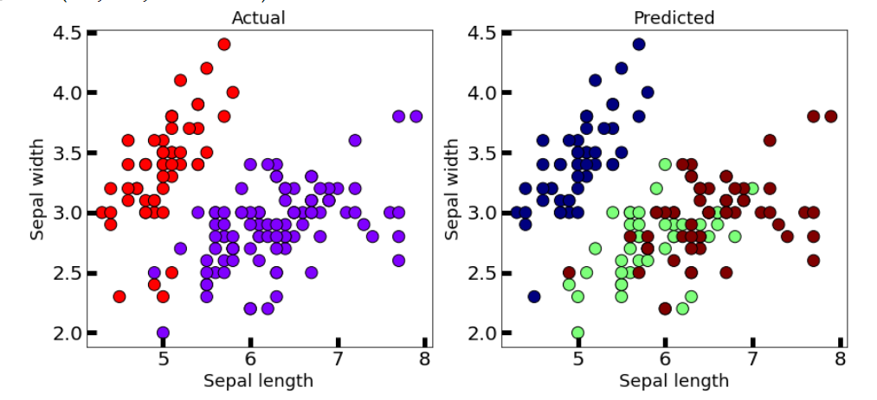

**9.2) WINE DATASET**

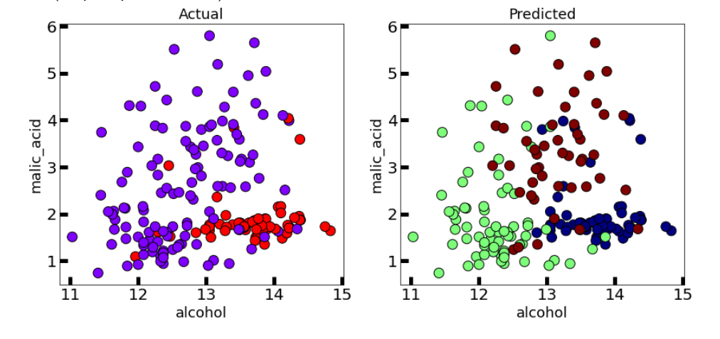

**Bisecting K-means clustering technique is a little modification to the regular K-Means algorithm, wherein we can fix the procedure of dividing the data into clusters.**

**So, similar to K-means, we first initialize K centroids (You can either do this randomly or can have some prior).**

**After which we apply regular K-means with K=2 (that’s why the word bisecting). We keep repeating this bisection step until the desired number of clusters are reached.**